Home automation using Arduino Nano

And bluetooth

# Guide:- Smita Samart Mande, Group leader:-Rutuj Nagrale , Group members:- Aditya Nagrale, Hrucha G Nagre, Sumaiyya J Nadaf

z

# Department of Engineering, Sciences and Humanities (DESH)

***Abstract****: This paper presents a low cost and flexible home control and environmental monitoring system. It employs an embedded micro – web server in Arduino Mega 2560 microcontroller, with IP connectivity for accessing and controlling devices and appliances remotely. These devices can be controlled through a web application or via Bluetooth Android based Smart phone app.* *With the availability of products which integrate mobile devices and cloud networking rapidly increasing, many users can see how new technology can impact their everyday lives. In this paper we have developed a Home Automation system that employs the integration of multi-touch mobile devices, cloud networking, wireless communication, and power-line communication to provide the user with remote control of various lights and appliances within their home. This system uses a consolidation of a mobile phone application, handheld wireless remote, and PC based program to provide a means of user interface to the consumer. The home automation system differs from other systems by allowing the user to operate the system without the dependency of a mobile carrier or Internet connection via the in-home wireless remote. This system is designed to be low cost and expandable allowing a variety of devices to be controlled.*

***Keywords*** *— Smart Home, Home Automation, Android Smartphone, Arduino, Light Dependent Resistor, Passive Infrared Sensor, Graphic User Interface*

1. INTRODUCTION

Until fairly recently, automated central control of building-wide systems was found only in larger commercial buildings and expensive homes. Typically involving only lighting, heating and cooling systems, building automation rarely provided more than basic control, monitoring and scheduling functions and was accessible only from specific control points within the building itself. Home automation is a step toward what is referred to as the Internet of Things, in which everything has an assigned IP address, and can be monitored and accessed remotely.

The first and most obvious beneficiaries of this approach are smart devices and appliances that connect to a local area network, via Ethernet or Wi-Fi. However, electrical systems and even individual points, like light switches and electrical outlets, were also integrated into home automation networks, and businesses have even explored the potential of IP-based inventory tracking. Although the day is still far off when you’ll be able to use your mobile browser to track down a lost sock, home networks are capable of including an increasing number of devices and systems.

Automation is, unsurprisingly, one of the two main characteristics of home automation. Automation refers to the ability to program and schedule events for the devices on the network. The programming may include time-related commands, such as having your lights turn on or off at specific times each day. It can also include non-scheduled events, such as turning on all the lights in your home when your security system alarm is triggered. Once you start to understand the possibilities of home automation scheduling, you can come up with any number of useful and creative solutions to make your life better.

Today’s home automation systems are more likely to distribute programming and monitoring control between a dedicated device in the home, like the control panel of a security system, and a user-friendly app interface that can be accessed via an Internet-enabled PC, smartphone or tablet. Manufacturers have produced a wide variety of smart devices, many of which are full of innovative features but few of which offer the kind of integration needed to be part of a complete home automation system. Much of the problem has been that each manufacturer has a different idea of how these devices should be connected and controlled. So while you may have a smart TV, washing machine, refrigerator, thermostat, coffee maker or any of the other Internet-ready household devices on the market, the end result is usually a separate control scheme for each device.

1. LITERATURE REVIEW

Time is a precious thing; everybody wants to save time as much as they can. In the world full of technology home automation is being needed due to hectic schedule. Home automation is the use of one or more computerized remote to control the basic home appliances remotely and sometimes automatically. It is designed to contr1ol appliances such as lighting points, entertainment systems, and home security such as access control as well as alarm systems. Connecting appliances through smartphone is useful for the elderly and physically disabled persons, who can access and control the appliances from where they are located and access them remotely without the help of others. The attractiveness of controlling electrical devices through a phone has been increasing because of its high performance and availability.

Nisar and Ibrahim proposed "a smart home model using android application" the home model uses ZigBee module to communicate between the android phone and the smart home model. This is not an effective medium of communication, as an external ZigBee transceiver must be connected to android phone. This leads to waste in power, use of many components as compare to the Bluetooth that is part of an android phone already. A low-cost Bluetooth based home automation system using an Android phone was presented by. An Arduino Mega 2560-R3 board and relays were used to connect the home appliances as input/output ports of the board, a Bluetooth were used to establish wireless communication between them.

Automation is the most commonly spelled word in technology sector. The hunger for automation has brought many revolutions to the current technologies. The planet is becoming more technologically advanced, industrial automation becoming more popular. This proposed system represents the detailed analysis of economic automation using Bluetooth module and the PIC microcontroller. The paper is particularly focused on the implementation of a prototype system for the industrial appliances a bit like the speed of the motor and to perform the ON/OFF function of the motor using the Bluetooth technology.

The section describes the previous works related to our proposed system. Many great contributors had placed a plentiful sign in the field of IoT, including home automation. As the author is using LoRa for this project. The authors tried to figure out how a low-power and low-cost but long-range communication devices are responsible for making IoT-based solutions. They had used radio communication spread spectrum such as LoRa for the development of their methodology.

A significant recent technological development concerns the automation of the knowledge and the service work as a result of the advances in Artificial Intelligence (AI) and its sub-fields. They have used the term Intelligent Automation to describe this phenomenon. This development presents organisations with a new strategic opportunity to increase business value. A business value-based model of Intelligent Automation for knowledge and service work and identify twelve research gaps that hinder a complete understanding of the business value realisation process.

Smart Home Models are used to monitor and to control home appliances through various methods, such as ZigBee, Bluetooth, and SMS. With the rapid growth of technology, the smart home model based on the Android application is designed for use in Android Smartphones. The smart home model will be able to the ease the effort of physically challenged individuals in controlling their home appliances, such as lamps, fan, and Television.

1. METHODOLOGY/EXPERIMENTAL
2. *Materials/Components/Flowchart/Block Diagram/Theory*

Turn on the application

Check all the appliances

Turn any appliances on or off as per your wishes

All the applications connected can be controlled through this application

1. *Synthesis/Algorithm/Design/Method*

**Design:**

The design of this project would require Arduino coding alongwith some hardware coding.

1. *Characterization/Pseudo Code/ Testing*

First, all the parts needed to design the project are collected and a primary concept is designed based on it.Then, the connection between the Arduino Uno and the Bluetooth via the Bluetooth module. After all the connection is being done, the Arduino board needs to be programmed and the Arduino software has to be installed. In the end, The Android based mobile phone is used to control the Arduino Uno via Bluetooth.

1. RESULTS AND DISCUSSIONS

One can command it to control small things of home through voice and Smartphones. All the tech giants are working in the field of IoT to bring advancements in the home automation devices. In near future, homes will be equipped with such IoT devices which will make your daily lives work faster smoother and more accurate.  
Mark Zuckerberg came up with a goofy proof-of-concept video showing off an idealized version of how his Jarvis system actually works. The devices which we use to use like television, refrigerator and even the mirror is getting smarter today with evolution of technology. The smart mirror should not only act as a face video but also help to other tasks like listening to music and stuff.

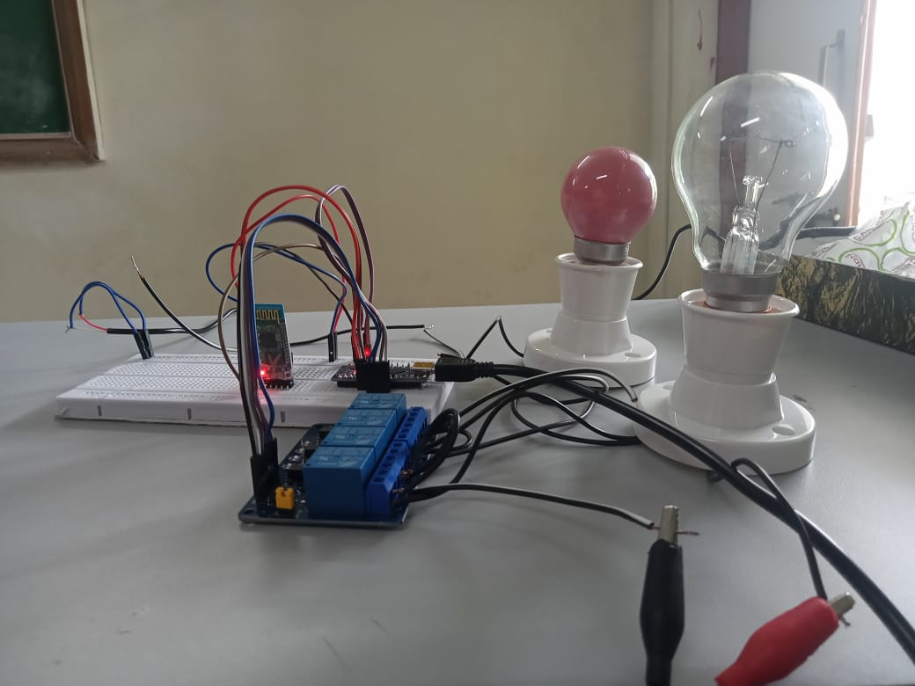

Figure 1

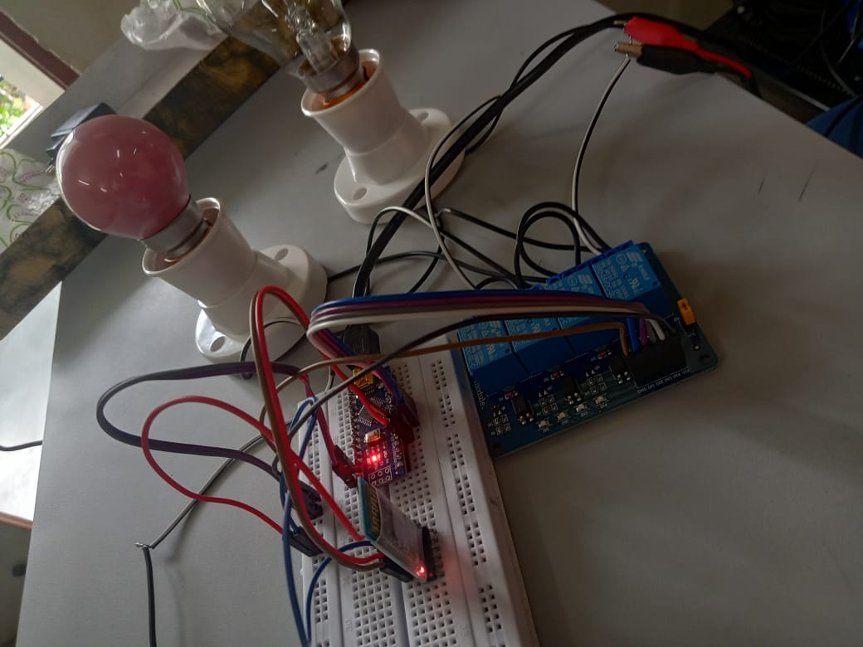

Figure 2

V.LIMITATIONS

Initially, when all the connections were done, the major problem was the connection between the Bluetooth module and the Arduino Uno. It was repeatedly unsuccessful because the Xbee module was used in the project. When the Xbee module was replaced with the HC-06, the connection was only established after reading about the specifications of the XBEE module and the HC-06 online.

A second problem was also encountered with the use of the fixing of the optocouplers on the board.

VI.FUTURE SCOPE

Implements more hardware and software interface modules, and modify server application software to handle them.

Modify hardware interface module to be able to communicates with sensors and actuators that use wireless technologies like X10, Zigbee, etc. To increase the range of our Bluetooth devices which is going to be connected to our home automation. By doing this system will increase system mobility, configurable, and scalability. Replace the bluetooth module with more reliable and stable bluetooth module, to increase system reliability. And the app which we have make with it will also have a easy to use user interface.

VII.CONCLUSION

It can be concluded from the above discussion that Home automation is a special kind of device which controls home appliances without extra effort. And it will also make human effort less. And form this, we demonstrated how the home automation is made, discussed about methodology and what its application can be.

The need of making a device is to create a device which saves the electricity and improve human life style and also cost less compare to the home automation which are in the online and offline market.

ACKNOWLEDGMENT

So finally we would like to express our gratitude to our guide miss Smita Mande without whom we would not have had the opportunity to make this project . we would like to thank all our team members for helping to shape this app and develop this project in a better way .

REFERENCES

[1]. Kashif Nisar & Ag Asri Ag Ibrahim , A Smart Home Model Using Android Application, 2018.

[02]. Crispin Coombs , Donald Hislop , Stanimaira k. Taneva , Sarah Barnard. The strategic impacts of Intelligent Automation for knowledge and service work: An interdisciplinary review. 2020

[03]]. Rahabul Islam, Md. Wahidur Rahman, Rahmina Rubaiat, Md. Mahmodul Hasan, Md. Mahfuz Reza, Mohammad Motiur Rahman , LoRa and server-based home automation using the internet of things (IOT). 2020

[04] S. Karthick ,Venkatesa Prabhu Sundarmurthy , Susheela Devi B. Devaru , Rakesh Narayanswamy, Anand Mohan, Sailesh Chandra Akkaraju , M. Jemaimah Carmichael , T.C. Manjunath , Realization of industrial automation using Bluetooth technologies.

2021.

[05]. Abiodun E. Amoran, Ayodele S.Oluwole, Enaitan O. Fagorola, R.S. Diarah. Home automated system using Bluetooth and an android application , 2021

[06] Voice controlled home automation | home automation using Arduino blutooth | IOT | Part 2

[Voice Controlled Home Automation | Home Automation Using Arduino Bluetooth | IOT | Part 2 - YouTube](https://www.youtube.com/watch?v=hkOUWIv6v-w)

[07]. How to make arduinao based home appliance control using Arduino

[How to make Arduino based Home Appliance Control Using Android Application | Home Automation Project - YouTube](https://www.youtube.com/watch?v=zRcRMdh7F-c)

[08]. Basis concept of Arduino in hindi

[How to make Arduino based Home Appliance Control Using Android Application | Home Automation Project - YouTube](https://www.youtube.com/watch?v=zRcRMdh7F-c)

[9]. Angga risky modern dashboard design <https://www.youtube.com/watch?v=LyymtbgnT6c>